

EMPLOYEE LEAVE AND PAYROLL MANAGAMENT SYSTEM – Sprint 2

Course: Software Engineering
Instructor: Ms. Rabail Zahid

Submission Date: 25th March 2025

BY:
The Scytes
Ruhab Ahmad (23I-0559)
Hasan Altaf (23I-0698)
Muhammad Saqib (23I-0769)

SPRINT 2 MODULE
Logout & Employee Management Module

SPRINT 2 OVERVIEW
Sprint Duration: March 1st, 2026 – March 25th, 2026
Sprint Goal: Implement administrative access controls and individual employee portal functionality.
Modules Developed in Sprint 2: Logout & Employee Management Module.

SPRINT 2 BACKLOG
- List the user stories selected for Sprint 2 using the proper user story template:
US-03 - View Employee Records (Leftover)
As an HR Admin I want to view employee list So that I can manage employee data
US-04 - Logout from System (Leftover)
As a System User I want to logout securely So that unauthorized access is prevented
Employee Management
US-05 - Update Employee Record
As an HR Admin, I want to update employee information so that records remain accurate.
US-06 - Delete Employee Record
As an HR Admin, I want to remove employee records so that inactive employees are not stored.
- Include sub-user stories and task breakdowns here.
US-03 – View Employee Records (Leftover)
Sub-User Stories:
- US-03.1 – View list of all employees
- US-03.2 – Search employee by name/ID
- US-03.3 – Filter employees (department/designation)
- US-03.4 – View detailed employee profile
Task Breakdown:
- Design employee list UI
- Create backend API to fetch employee data
- Implement search functionality
- Implement filter options
- Create employee detail view page
- Connect frontend with backend APIs
- Testing (UI + functionality)
US-04 – Logout from System (Leftover)
Sub-User Stories:
- US-04.1 – Logout button visible on dashboard
- US-04.2 – Secure session termination
- US-04.3 – Redirect to login page after logout
Task Breakdown:
- Add logout button in UI
- Implement logout API / session destroy logic
- Clear authentication tokens/session
- Redirect user to login screen
- Handle unauthorized access after logout
- Testing (security + navigation)
US-05 – Update Employee Record
Sub-User Stories:
- US-05.1 – Edit employee information form
- US-05.2 – Validate input fields
- US-05.3 – Save updated employee data
- US-05.4 – Show success/error messages
Task Breakdown:
- Design edit employee form UI
- Pre-fill form with existing employee data
- Implement input validation (required fields, formats)
- Create/update API endpoint for employee update
- Handle success & error responses
- Update UI after successful edit
- Testing (validation + update flow)
US-06 – Delete Employee Record
Sub-User Stories:
- US-06.1 – Delete button for each employee
- US-06.2 – Confirmation prompt before deletion
- US-06.3 – Remove employee from database
- US-06.4 – Update UI after deletion
Task Breakdown:
- Add delete button in employee list
- Implement confirmation dialog (Are you sure?)
- Create API endpoint for delete operation
- Remove employee record from database
- Refresh employee list after deletion
- Handle error cases (e.g., deletion failure)
- Testing (delete flow + edge cases)

STRUCTURED SPECIFICATIONS
1. View Employees
Inputs:
- Request from HR Admin (view employee list)
Processing:
- Validate admin authentication
- Fetch employee records from database
- Apply optional filters/search (if any)
- Format data for display
Outputs:
- List of employee records displayed on screen
Preconditions:
- User must be logged in as HR Admin
- Database connection is active
Postconditions:
- Employee list is successfully displayed to the admin
2. Logout
Inputs:
- Logout request from user
Processing:
- Invalidate user session
- Clear authentication tokens/cookies
- Redirect user to login page
Outputs:
- User is redirected to login page
Preconditions:
- User must be logged into the system
Postconditions:
- Session is terminated
- User cannot access protected resources without logging in again
3. Update Employee Record
Inputs:
- Employee ID
- Updated employee details (name, department, etc.)
Processing:
- Validate input data (format, required fields)
- Verify employee exists in database
- Update employee record in database
- Save changes
Outputs:
- Confirmation message (success/failure)
Preconditions:
- User must be logged in as HR Admin
- Employee record must exist
Postconditions:
- Employee data is updated in database
- Updated information is reflected in system
4. Delete Employee Record
Inputs:
- Employee ID
Processing:
- Verify employee exists in database
- Confirm deletion request
- Remove employee record from database
Outputs:
- Deletion confirmation message
Preconditions:
- User must be logged in as HR Admin
- Employee record must exist
Postconditions:
- Employee record is permanently removed
- Employee no longer appears in the system

SCRUM BOARD
- Initial backlog uploaded:
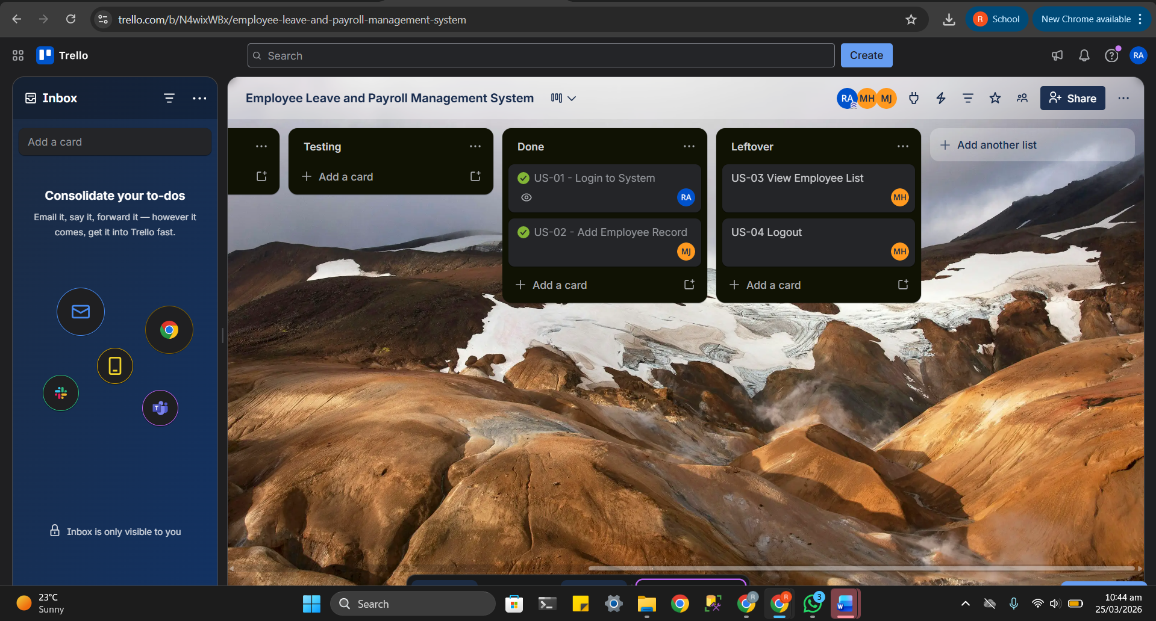
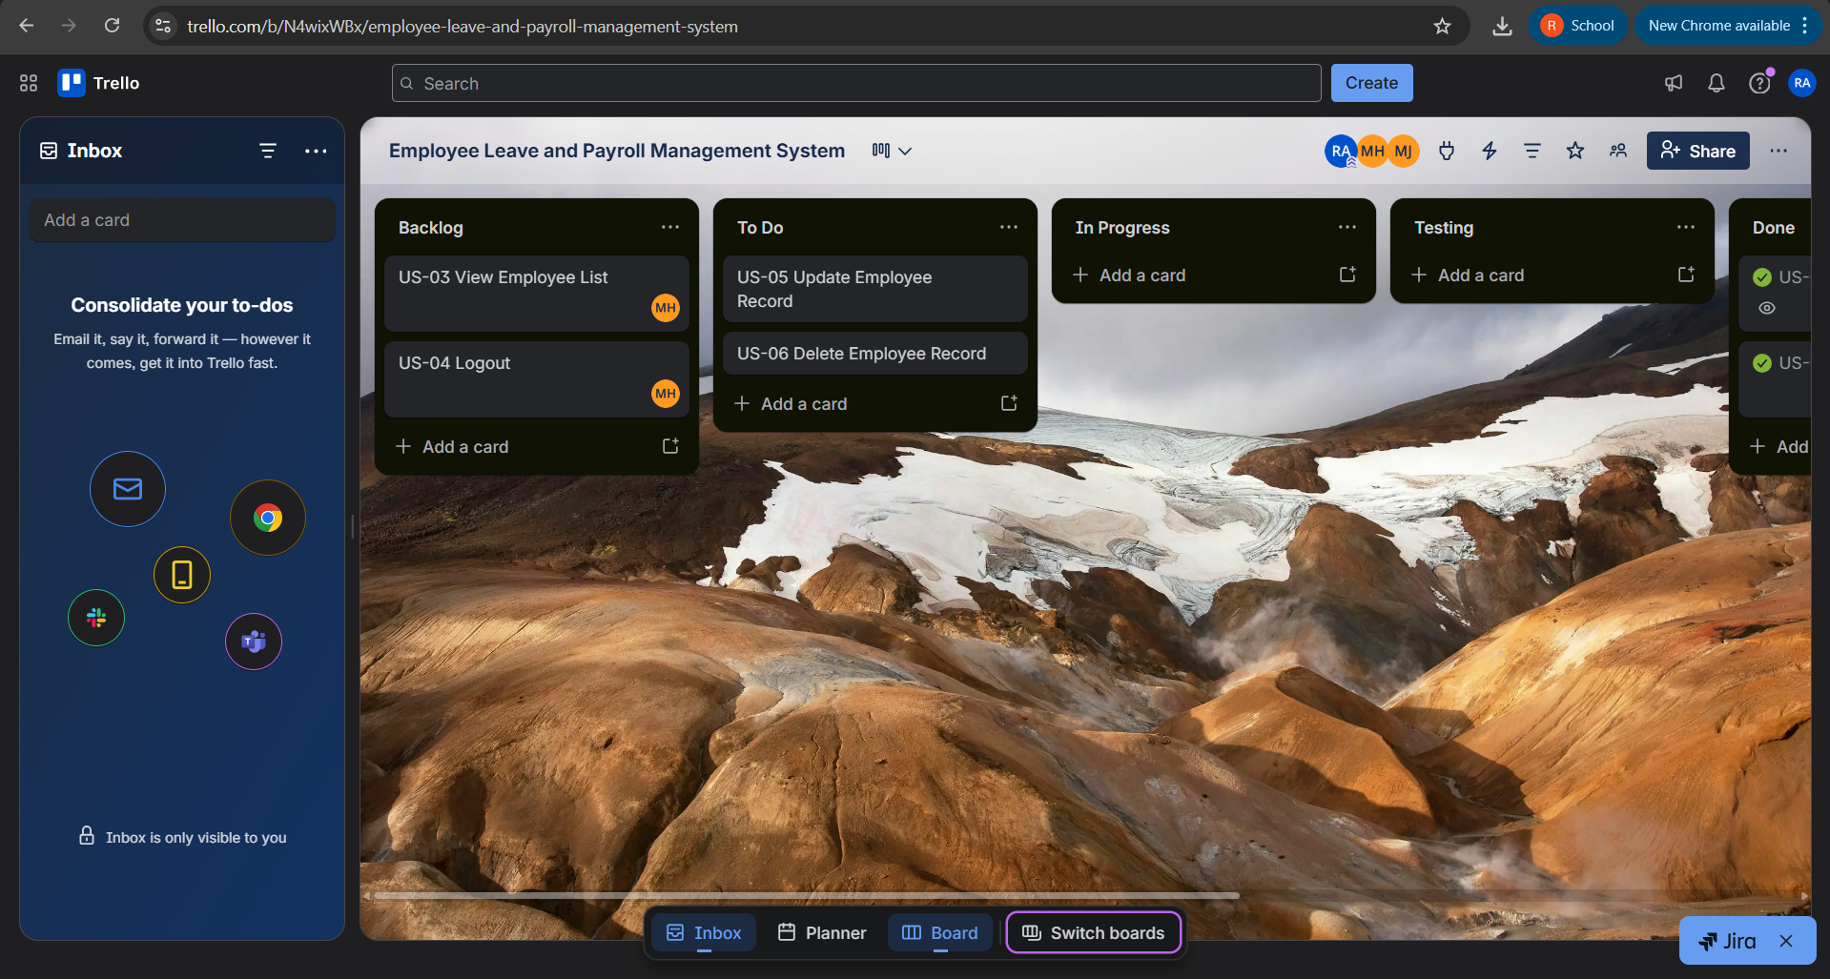
- Mid-sprint progress:
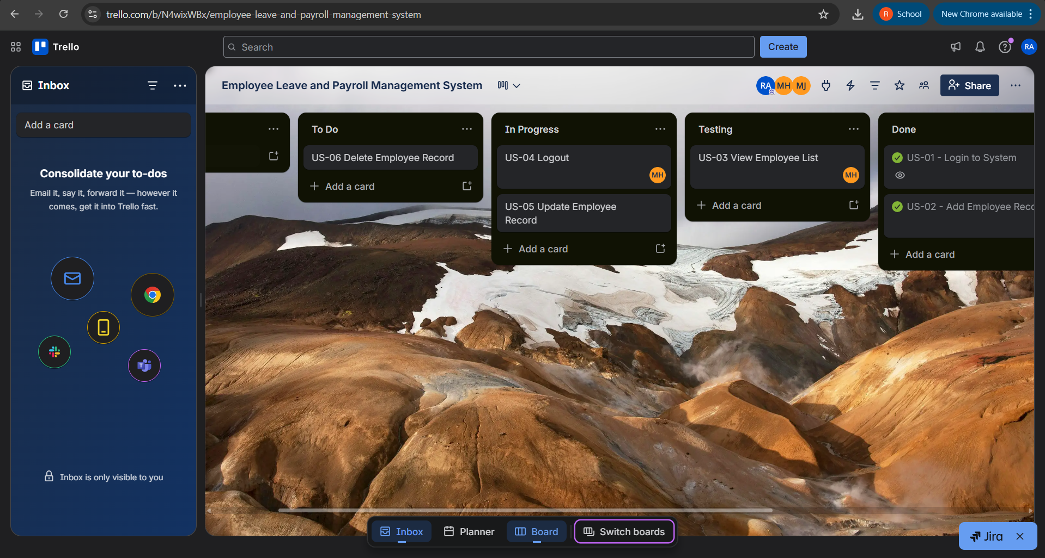
- Final sprint status:
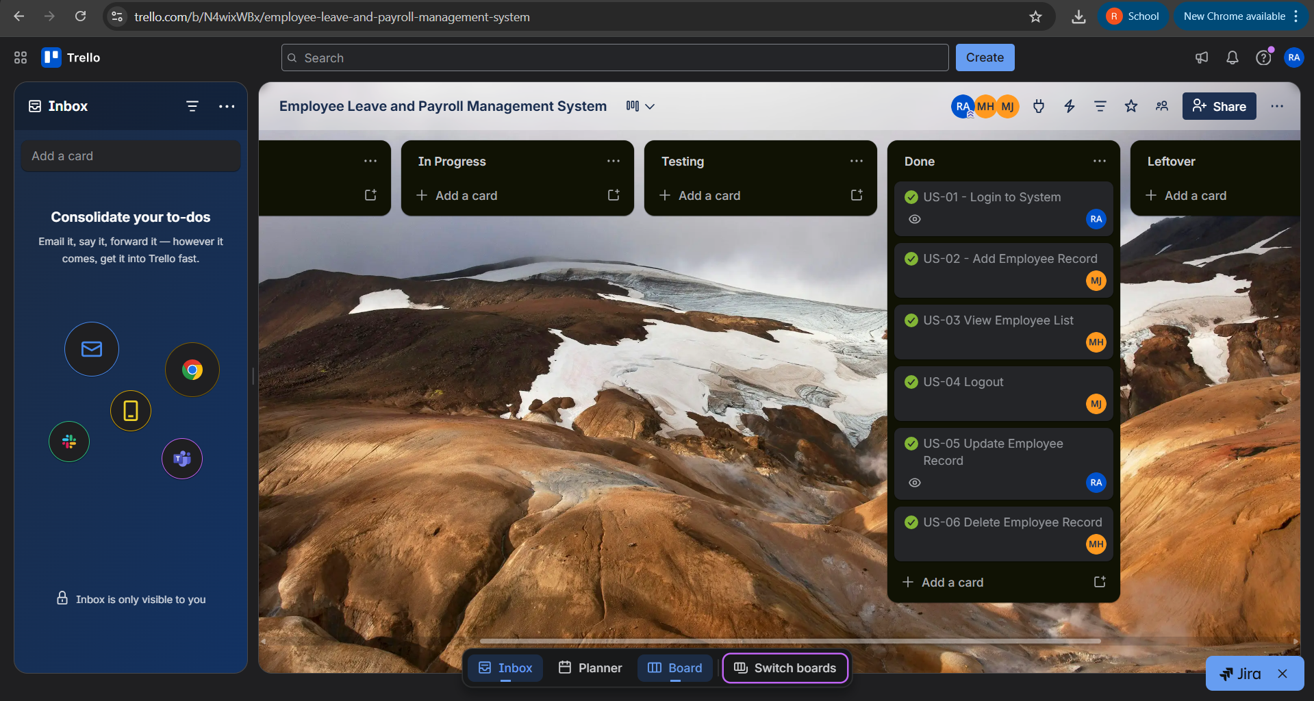

PRODUCT BURN DOWN CHART
